SCSI Interlock Protocol

BigSur Communications

Written by: Jeffrey Fall
For Steve Parks and Company

Introduction 4
Basic SCSI topology 4
Basic SCSI states 4
SCSI states with respect to bus signals 7
Information transfer phases 8
SCSI State Machine 9
SCSI Message Definitions 13
ABORT 13
ABORT TAG 13
BUS DEVICE RESET 14
CLEAR QUEUE 14
COMMAND COMPLETE 14
DISCONNECT 15
IDENTIFY 15
IGNORE WIDE RESIDUE 17
INITIATE RECOVERY 18
INITIATOR DETECTED ERROR 18
LINKED COMMAND COMPLETE 18
LINKED COMMAND COMPLETE (WITH FLAG) 19
MESSAGE PARITY ERROR 19
MESSAGE REJECT 19
MODIFY DATA POINTER Message 20
NO OPERATION 20
QUEUE TAG MESSAGES 20
HEAD OF QUEUE TAG 21
ORDERED QUEUE TAG 21
SIMPLE QUEUE TAG 22
RELEASE RECOVERY 22
RESTORE POINTERS 22
SAVE DATA POINTER 22
SYNCHRONOUS DATA TRANSFER REQUEST message 23
TERMINATE I/O PROCESS 25
WIDE DATA TRANSFER REQUEST message 26
SCSI BUS Status codes 28
Definition of SCSI status codes 29
SCSI Commands 30
Introduction 30
10 byte CDB 30
12 byte CDB 31
16 byte CDB (SCSI-3) To be added 31
SCSI Command hierarchy 31
Commands for all device types 32
Direct access commands (disk drive) 32
Sequential Devices (tape drive) 34
SCSI State Machine Architecture 35
I_T_L_Q Nexus basic host requirements 35
Introduction 35
Nexus expanded for FC and iSCSI 36
Example expanded Nexus 36
Concept of SCSI process 37
Contents of Nexus table 37
Implementing SCSI BUS STATES in hardware 37
STATE: “BUS FREE” → “ARBITRATION” 38
STATE “ARBITRATION” → “SELECTION” 39
SELECTION time-out procedure 40
STATE “ARBITRATION” → “RESELECTION 40
RESELECTION 40
RESELECTION time-out procedure 41
Information transfer phases 41
Information transfer phases 42
Asynchronous information transfer 43
Synchronous data transfer 43
Wide data transfer 45
Wide SCSI byte ordering 46
SCSI Bus phase summary: 47
COMMAND phase 47
Data phase 47
DATA IN phase 47
DATA OUT phase 47
STATUS phase 47
Message phase 47
MESSAGE IN phase 48
MESSAGE OUT phase 48
MESSAGE OUT 49
COMMAND phase. 49

Introduction

This document describes the SCSI protocol from the perspective of implementing as much of the protocol as possible in hardware. SCSI states will be covered as well as timing.

Emphasis will be placed on the SCSI Interlock Protocol (SIP) which is a lower layer in the Common Access Model (CAM) specification. The SIP layer relies on hardware states assumed by the SCSI bus for phase state transitions

All of the states in SIP are by definition a Boolean expression of data and signal lines on the SCSI bus.

Each state may or may not have commands, data, messages or status associated with it.

This document will attempt to define the state diagram with data structures and permutations needed for the hardware designer to attain a firm grasp of the SIP, SCSI Interlock Protocol.

Basic SCSI topology

SCSI views SCSI devices as Initiators and Targets. The great majority of SCSI buses have one Initiator and one or more targets. Some SCSI busses in Enterprise Storage Applications (High Availability) contain two initiators. Each initiator resides on a different server and the SCSI bus links the servers to a disk farm or RAID.

Initiators “initiate” SCSI requests. In a client

Basic SCSI states

0 BUS FREE. The SCSI state machine always begins at BUS FREE. BUS FREE is a quiescent state meaning there are no data or signals present. The SCSI bus is an active LOW state for TRUE condition. BUS FREE can only transition to ARBITRATE.

1 ARBITRATE. Arbitration is the only state possible after BUS FREE. A device arbitrating for the bus is trying to gain control of the SCSI bus. If there are numerous SCSI devices, both initiators and targets (all devices are equal in arbitration), the device with the greatest (highest) target ID will win arbitration of the bus. (Target ID is a loose term for ID. As mostly target ID’s are changed, “target ID” is usually the identification of the device set by the owner or user of the device either through jumpers or by firmware configuration. In summary, the device with the maximum SCSI ID wins arbitration. Arbitration can be caused by an initiator trying to gain control of the bus, or from a target trying to reselect the bus after it disconnected. A good “polite” target will disconnect from the SCSI bus if it can not supply data due to latency with in the device. For example, a disk drive could be trying to find the requested block and the heads are waiting for the media to be present under the read head(s). Once the data is ready in the target, it will reselect the initiator. But, it must first regain control of the bus.

2 SELECTION has been reached from the Arbitration state by an initiator who has successfully arbitrated. The initiator impresses the binary number of the target ID it wishes to communicate with. The target responds, the SELECTION state ends and the state machine transitions to MESSAGE OUT.

2 RESELECTION has been reached from the Arbitration state by a target who has successfully arbitrated. The target impresses the binary number of the initiator ID it wishes to communicate with. The initiator responds, the RESELECTION state ends and the state machine transitions to MESSAGE IN.

3 MESSAGE OUT. Messages are the system which SCSI handles state transitions. Messages are all verbs and require action on the part of the initiator or target. Message OUT are messages OUT from the initiator to the target. (see message table). Messages do not allow the target or initiator to perform useful “work”. Work transferring data to/from or from/to targets and initiators. Messages are overhead. The first message sent by the initiator after the SELECTION phase shall be an IDENTIFY, ABORT, or BUS DEVICE
RESET message. If a target receives any other message it shall go to BUS FREE phase.

3 MESSAGE IN. Messages are the system which SCSI handles state transitions. Messages are all verbs and require action on the part of the initiator or target. Message IN are messages IN from the target to the initiator. Messages are used to handle async events affecting the current SCSI bus state or task under process. (see message table). Messages do not allow the target or initiator to perform useful “work”. Work transferring data to/from or from/to targets and initiators. Messages are overhead. After the RESELECTION phase, the target’s first message shall be IDENTIFY. This allows
the I_T_L nexus or I_T_R nexus to be reestablished. Only one logical unit or target routine shall be identified for any connection. If a target receives a second IDENTIFY message with a different logical unit number or target routine number during a connection, it shall go to BUS FREE phase.

4 COMMAND. Commands are used control SCSI devices (targets) to produce a useful action for the requestor. Traditionally, Device Drivers are concerned with manufacturing and sending CCBs to a SCSI device. In this sense, the SCSI state machine is mostly contained in the “host adapter”. The driver is only concerned with getting a CCB out to the target and having the command executed.

Many SCSI drivers written have a “pass through” mode which allows an application level process the ability to send CCBs directly to the SCSI target bypassing the SCSI driver. The SCSI driver and host adapter are then viewed as simply the SCSI state engine which processes CCBs and returns status.

Commands are encased in CCB data structures which are 10, 12 and 16 bytes long. SCSI-1 used 6 byte CCB structures which should now be avoided. CCB data structures are transferred to the SELECTed SCSI device. The firmware of the SELECTed SCSI device parses the command opcode of the CCB. The command opcode may be a command which requires the target to have additional data. Additional data is usually a logical disk block to read or write to and a byte count. The permutations are many but are finite. Commands are grouped as general SCSI commands or as Device Specific commands. As an example, Disk Drives have a finite number of supported SCSI command CCBs as do SCSI printers, scanners, cdroms, optical devices, ect. A device driver uses the IDENTIFY command (actually just an opcode in a CCB) to tell a SCSI device to return the vendor supplied device string which describes the device. The string will tell what type of device it is, printer, disk, ect and an actual text readable ASCII string which verbally describes the device. This feature is useful to ascertain the device firmware level (if encoded by the vendor). Updating the SCSI device firmware usually makes this string change value. (This is of concern only to the device driver writer)

4 DATA IN or DATA OUT. Data is moved in or out of the target along the SCSI bus with respect to the initiator. There are two modes of DATA transfer.

- Asynchronous. Data is moved “data bus width” at a time. 1 byte for an 8 bit wide SCSI bus, 2 bytes for a 16 bit wide SCSI bus and so forth. Handshaking is in effect for each byte or word of data. A REQ/ACK pair is needed for each data unit transferred. Some vendors can make this work up to 10 MB/Sec or so. This is not a desired mode for transferring data quickly. SCSI devices are not ever rated on Asynchronous data transfer ability but on synchronous. All SCSI devices start off communicating with Asynchronous data transfer. The purpose for this is it is the lowest common denominator for clean communication. Synchronous data transmission can not be assumed initially as this rate is subject to agreement between the devices beforehand. A SCSI device reset will cause all devices to default to asynchronous data transfer mode. A SCSI bus reset – the “reset” line pulled low causes the firmware in each SCSI target to perform a warm reset.
- Synchronous. Data is clocked over the bus at a rate which has been agreed upon between two SCSI devices. The Synchronous Data Transfer Message is sent with best case clocking parameters of the requesting device. The responding device can agree and accept the parameters by echoing back the same parameters or send back the maximum transfer parameters (degraded original rate) which it can perform. The requesting device will compare these parameters with its own and use the LOWEST parameters offered from itself or the other device. The period is expressed as an offset. This is the number of clock pulses allowed before an ACK is required.

- STATUS. Is used to determine the success or failure of a message or command. Messages and commands change the state of the target state machine and status is used to return the effect of the command or message. See status table in next sections.

SCSI states with respect to bus signals

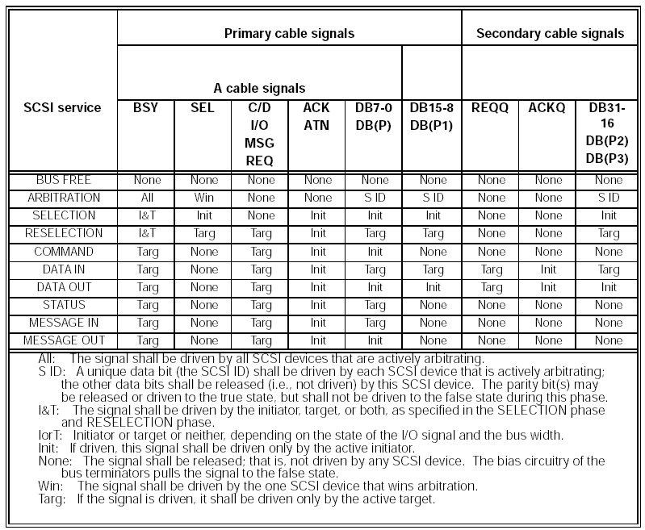

Information transfer phases

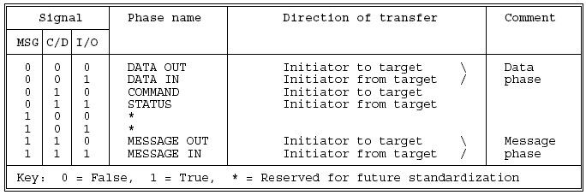

SCSI State Machine
States from the introduction area of this document are broken out. Note, the only terminal state is “BUS FREE”. This small state tree is the entire SCSI protocol. Note: for infinite data, the state diagram can be infinitely recursive.

1 “BUS FREE” → “ARBITRATION”

2 “ARBITRATION” → “SELECTION” OR “RESLELCTION”

3 “SELECTION” → “MESSAGE OUT”
3 “RESELECTION” → “MESSAGE IN”

4 “MESSAGE OUT” → “COMMAND”
→ “DATA IN”
→ “DATA OUT”
→ “STATUS”
→ “MESSAGE IN”

- “COMMAND” → “DATA IN”
→ “DATA OUT”
→ “STATUS”
→ “MESSAGE IN”

6 “DATA IN” → “STATUS”
→ “MESSAGE IN”
→ “MESSAGE OUT”

6 “DATA OUT” → “STATUS”
→ “MESSAGE IN”
→ “MESSAGE OUT”

7 “STATUS” → “MESSAGE IN”

8 “MESSAGE IN” → “BUS FREE”

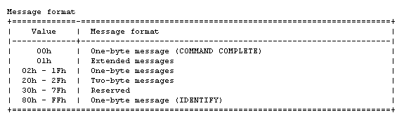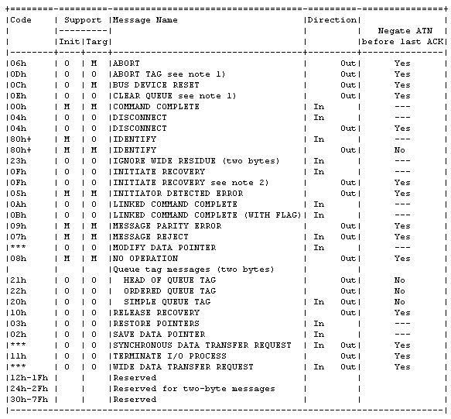
BUS FREE
ARB
Message
IN
Status
Data IN or OUT
Command
Message
OUT
SEL
Basic SCSI state diagram (messages)
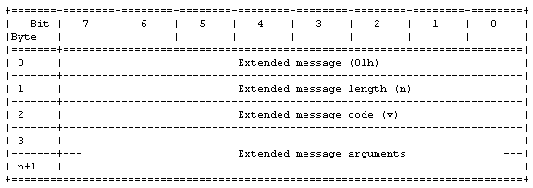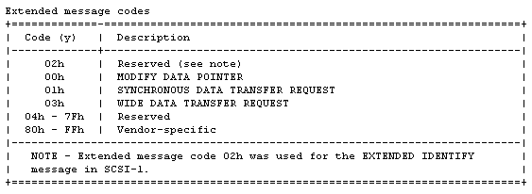
BUS FREE
ARB
Message
IN
Status
Data IN or OUT
Command
Message
OUT
SEL
Basic SCSI state diagram (messages)

SCSI Message Definitions

Understanding the operation of the SCSI messaging system is essential to implement the state machine.

ABORT
The ABORT message is sent from the initiator to the target to clear any I/O process for the I_T_x nexus. The target shall go to the BUS FREE phase following successful receipt of this message. The pending data, status, and I/O processes for any other nexus shall not be cleared. If only an I_T nexus has been established, the target shall go to the BUS FREE phase. No status or message shall be sent for the current I/O process and no other I/O process shall be affected. The ABORT message in the case of only an I_T nexus is useful to an initiator that cannot get an IDENTIFY message
through to the target due to parity errors and just needs to end the current connection. Any pending data, status, or queued I/O processes for the I_T nexus is not affected.
It is not possible to abort an I_T nexus on a reconnection)
It is not an error to issue this message to an I_T_x nexus that does not have an active or queued I/O process.

Previously established conditions, including MODE SELECT parameters, reservations, and extended contingent allegiance shall not be changed by the ABORT message.

NOTE: The BUS DEVICE RESET, CLEAR QUEUE, ABORT, and ABORT TAG messages provide a means to clear one or more I/O processes prior to normal termination. The BUS DEVICE RESET message clears all I/O processes for all initiators on all logical units and all target routines of the target. The CLEAR QUEUE message clears all I/O processes for all initiators on the specified logical unit or target routine of the target. The ABORT message clears all I/O processes for the selecting initiator on the specified logical unit or target routine of the target. The ABORT TAG message clears the current
I/O process only.

ABORT TAG
The ABORT TAG message shall be implemented if tagged queuing is implemented and may be implemented if untagged queuing is implemented. The target shall go to the BUS FREE phase following successful receipt of this message. The target shall clear the current I/O process. If the target has already started execution of the I/O process,
the execution shall be halted. The medium contents may have been modified before the execution was halted. In either case, any pending status or data for the I/O process shall be cleared and no status or ending message shall be sent to the initiator. Pending status, data, and commands for other active or queued I/O processes shall not be
affected. Execution of other I/O processes queued for the I_T_x nexus shall not be aborted. Previously established conditions, including MODE SELECT parameters, reservations, and extended contingent allegiance shall not be changed by the ABORT TAG message.
On a reconnection, the ABORT TAG message aborts the current I/O process if it is fully identified. If the I/O process is not fully identified (i.e. an I_T_L nexus exists, but the target is reconnecting for an I_T_L_Q nexus), then the I/O process is not aborted and the target goes to the BUS FREE phase.
NOTE: A nexus is not fully identified on a reconnection if the ATN signal is asserted during or prior to the IDENTIFY message and the target only has tagged I/O processes for that initiator on that logical unit.

BUS DEVICE RESET

The BUS DEVICE RESET message is sent from an initiator to direct a target to clear all I/O processes on that SCSI device. This message forces a hard reset condition to the selected SCSI device. The target shall go to the BUS FREE phase following successful receipt of this message. The target shall create a unit attention condition for all
Initiators

CLEAR QUEUE

The CLEAR QUEUE message shall be implemented if tagged queuing is implemented and may be implemented if untagged queuing is implemented. The target shall go to the BUS FREE phase following successful receipt of this message. The target shall perform an action equivalent to receiving a series of ABORT messages from each initiator.
All I/O processes, from all initiators, in the queue for the specified logical unit shall be cleared from the queue. All active I/O processes shall be terminated. The medium may have been altered by partially executed commands. All pending status and data for that logical unit or target routine for all initiators shall be cleared. No status or message
shall be sent for any of the I/O processes. A unit attention condition shall be generated for all other initiators with I/O processes that either were active or were queued for that logical unit or target routine. When reporting the unit attention condition the additional sense code shall be set to COMMANDS CLEARED BY ANOTHER INITIATOR.
Previously established conditions, including MODE SELECT parameters, reservations, and extended contingent allegiance shall not be changed by the CLEAR QUEUE message.

COMMAND COMPLETE

The COMMAND COMPLETE message is sent from a target to an initiator to indicate that the execution of an I/Oprocess has completed and that valid status has been sent to the initiator. After successfully sending this message, the target shall go to the BUS FREE phase by releasing the BSY signal. The target shall consider the message
transmission to be successful when it detects the negation of ACK for the COMMAND COMPLETE message with the ATN signal false.
NOTE: The I/O process may have completed successfully or unsuccessfully as indicated in the status.

DISCONNECT

The DISCONNECT message is sent from a target to inform an initiator that the present connection is going to be broken (the target plans to disconnect by releasing the BSY signal), but that a later reconnect will be required in order to complete the current I/O process. This message shall not cause the initiator to save the data pointer. After
successfully sending this message, the target shall go to the BUS FREE phase by releasing the BSY signal. The target shall consider the message transmission to be successful when it detects the negation of the ACK signal for the DISCONNECT message with the ATN signal false. Targets that break data transfers into multiple connections shall end each successful connection (except possibly the last) with a SAVE DATA POINTER - DISCONNECT message sequence.

This message may also be sent from an initiator to a target to instruct the target to disconnect from the SCSI bus. If this option is supported, and after the DISCONNECT message is received, the target shall switch to MESSAGE IN phase, send the DISCONNECT message to the initiator (possibly preceded by SAVE DATA POINTER message), and then disconnect by releasing BSY. After releasing the BSY signal, the target shall not participate in another ARBITRATION phase for at least a disconnection delay or the time limit specified in the disconnect time limit mode
parameter,whichever is greater. If this option is not supported or the target cannot disconnect at the time when it receives the DISCONNECT message from the initiator, the target shall respond by sending a MESSAGE
REJECT message to the initiator.

IDENTIFY

The IDENTIFY message (see table 13) is sent by either the initiator or the target to establish an I_T_L nexus or an I_T_R nexus.

NOTE: Use of the IDENTIFY message to establish an I_T_R nexus allows connection to one of up to eight target routines or functions in the target. These target routines are expected to be used for maintenance and diagnostic purposes.

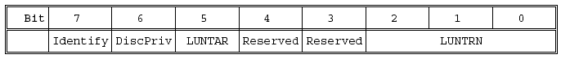
The identify bit shall be set to one to specify that this is an IDENTIFY message.
A disconnect privilege (DiscPriv) bit of one specifies that the initiator has granted the target the privilege of disconnecting. A DiscPriv bit of zero specifies that the target shall not disconnect. This bit is not defined and shall be set to zero when an IDENTIFY message is sent by a target.

A logical unit target (LUNTAR) bit of zero specifies that the I/O process is directed to or from a logical unit. A LUNTAR bit of one specifies that the I/O process is directed to or from a target routine.

The logical unit number target routine number (LUNTRN) field specifies a logical unit number if the LUNTAR bit is zero. The LUNTRN field specifies a target routine number if the LUNTAR bit is one. The response to an invalid value in the LUNTRN field is described elsewhere in this document. Only the INQUIRY and REQUEST SENSE commands are valid for target routines. If a target receives any other command for a target routine, it shall return CHECK CONDITION status and shall set the sense key to ILLEGAL REQUEST.

An IDENTIFY message is invalid if a reserved bit is set to one or if the LUNTAR bit is set to one and the target does not implement target routines. A device may respond to an invalid IDENTIFY message by immediately sending a MESSAGE REJECT message or by returning CHECK CONDITION status. If a CHECK CONDITION status is returned,
the sense key shall be set to ILLEGAL REQUEST and the additional sense code shall be set to INVALID BITS IN IDENTIFY MESSAGE FIELD.

Only one logical unit number or target routine number shall be identified per I/O process. The initiator may send one or more IDENTIFY messages during a connection. A second IDENTIFY message with a different value in either the LUNTAR bit or LUNTRN field shall not be issued before a BUS FREE phase has occurred; if a target receives a second IDENTIFY message with a different value in either of these fields, it shall go to BUS FREE phase (see unexpected disconnect).

Thus an initiator may change the DiscPriv bit, but may not attempt to switch to another
I/O process. (See the DTDC field of the disconnect-reconnect for additional controls over
disconnection.)

An implied RESTORE POINTERS message shall be performed by the initiator prior to the assertion of the ACK signal on the next phase for an inbound IDENTIFY message sent during reconnection. An implied RESTORE POINTERS message shall be performed by the initiator following successful identification of
the nexus during the MESSAGE IN phase of a reconnection and before the negation of the ACK signal for the next transfer following the successful identification.
Identification is considered successful during an initial connection or an initiator reconnect when the target detects no error during the transfer of the IDENTIFY message and an optional queue tag message in the MESSAGE OUT phase
immediately following the SELECTION phase. See 6.5 for the ordering of the IDENTIFY and queue tag messages.

Identification is considered successful during a target reconnect when the ATN signal is not asserted during the transfer of either the IDENTIFY message or the SIMPLE QUEUE TAG message for an I_T_L_Q nexus in the MESSAGE IN phase immediately following the RESELECTION phase. See clause 6.5 for the ordering of the IDENTIFY and queue
tag messages. See 6.2.1, item d), for handling target detected errors during the MESSAGE IN phase.

IGNORE WIDE RESIDUE

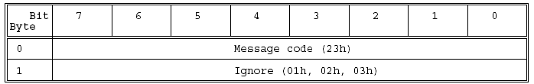

The IGNORE WIDE RESIDUE message (see table 14) shall be sent from a target to indicate that the number of valid bytes sent during the last REQ/ACK handshake and REQB/ACKB handshake of a DATA IN phase is less than the negotiated transfer width. The ignore field indicates the number of invalid data bytes transferred. This message shall be sent immediately following that DATA IN phase and prior to any other messages. The ignore field is defined in the table below.

NOTE: More than one IGNORE WIDE RESIDUE message may occur during an I/O process.

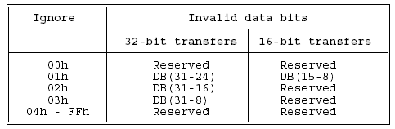

Even though a byte is invalid its corresponding parity bit shall be valid for the value transferred. For 16-bit transfers, DB(31-16) are always invalid and the corresponding parity bits are also invalid.

INITIATE RECOVERY

A target that supports extended contingent allegiance shall inform the initiator it is entering this condition by sending an INITIATE RECOVERY message immediately following a CHECK CONDITION or COMMAND TERMINATED status.

The extended contingent allegiance condition remains in effect until terminated as described in 7.7. If an asynchronous event occurs, the target may enter an extended contingent allegiance condition by becoming a temporary initiator and sending the INITIATE RECOVERY message following the IDENTIFY message and any queue
tag message and before the COMMAND phase of the SEND command that is used to perform the asynchronous event notification. The successful transmission of this message establishes the extended contingent allegiance condition which remains in effect until terminated as described in 7.7.

NOTE: If the target notifies multiple initiators of the asynchronous event, it should include the INITIATE RECOVERY message in only one of the notifications.
A MESSAGE REJECT response to an INITIATE RECOVERY message indicates that an extended contingent allegiance condition shall not be established. The enabled or disabled state of an extended contingent allegiance (see
8.3.3.1) is not changed by the rejection of an INITIATE RECOVERY message.

INITIATOR DETECTED ERROR

The INITIATOR DETECTED ERROR message is sent from an initiator to inform a target that an error has occurred that does not preclude the target from retrying the operation. The source of the error may either be related to previous activities on the SCSI bus or may be internal to the initiator and unrelated to any previous SCSI bus activity. Although present pointer integrity is not assured, a RESTORE POINTERS message or a disconnect followed by a reconnect, shall cause the pointers to be restored to their defined prior state.

LINKED COMMAND COMPLETE

The LINKED COMMAND COMPLETE message is sent from a target to an initiator to indicate that the execution of a linked command has completed and that status has been sent. The initiator shall then set the pointers to the initial state for the next linked command.

LINKED COMMAND COMPLETE (WITH FLAG)

The LINKED COMMAND COMPLETE (WITH FLAG) message is sent from a target to an initiator to indicate that the execution of a linked command (with the flag bit set to one) has completed and that status has been sent. The initiator shall then set the pointers to the initial state of the next linked command. Typically this message would be used to
cause an interrupt in the initiator between two linked commands.

MESSAGE PARITY ERROR

The MESSAGE PARITY ERROR message is sent from the initiator to the target to indicate that it received a message byte with a parity error.

In order to indicate its intentions of sending this message, the initiator shall assert the ATN signal prior to its release of the ACK signal for the REQ/ACK handshake of the message byte that has the parity error. This provides an interlock so that the target can determine which message byte has the parity error. If the target receives this message
under any other circumstance, it shall signal a catastrophic error condition by releasing the BSY signal without any further information transfer attempt.

If after receiving the MESSAGE PARITY ERROR message the target returns to the MESSAGE IN phase before switching to some other phase, the target shall resend the entire message that had the parity error.

MESSAGE REJECT

The MESSAGE REJECT message is sent from either the initiator or target to indicate that the last message or message byte it received was inappropriate or has not been implemented. In order to indicate its intentions of sending this message, the initiator shall assert the ATN signal prior to its release of the ACK signal for the REQ/ACK handshake of the message byte that is to be rejected. If the target receives this message under any other circumstance, it shall reject this message. When a target sends this message, it shall change to MESSAGE IN phase and send this message prior to requesting additional message bytes from the initiator. This provides an interlock so that the initiator can determine which message byte is rejected.

After a target sends a MESSAGE REJECT message and if the ATN signal is still asserted, then it shall return to the
MESSAGE OUT phase. The subsequent MESSAGE OUT phase shall begin with the first byte of a message.

MODIFY DATA POINTER Message

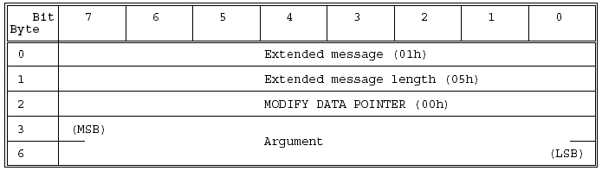

The MODIFY DATA POINTER message (see table above) is sent from the target to the initiator and requests that the signed argument be added (two’s complement) to the value of the current data pointer.

NO OPERATION

The NO OPERATION message is sent from an initiator in response to a target’s request for a message when the initiator does not currently have any other valid message to send.
For example, if the target does not respond to the attention condition until a later phase and at that time the original message is no longer valid the initiator may send the NO OPERATION message when the target enters the MESSAGE OUT phase.

QUEUE TAG MESSAGES
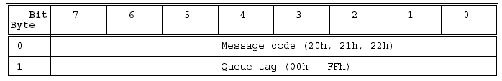
Table above defines the format for the queue tag messages. If the target implements tagged queuing, all of the queue tag messages are mandatory: HEAD OF QUEUE TAG, ORDERED QUEUE TAG, and SIMPLE QUEUE TAG. Tagged
queuing is only defined for logical units, not for target routines.

If a target does not implement tagged queuing and a queue tag message is received or if a queue tag message is received for a target routine, it shall respond with a MESSAGE REJECT message and accept the I/O process as if it were untagged.

The queue tag messages are used to specify an identifier, called a queue tag, for the I/O process that establishes the
I_T_L_Q nexus. The queue tag field is an 8-bit unsigned integer assigned by the initiator during an initial connection.

The queue tag for every I/O process for each I_T_L nexus should be unique. If the target receives a queue tag that is currently in use for the I_T_L nexus, then it shall respond as defined in 7.5.2. A queue tag becomes available for reassignment when the I/O process ends. The numeric value of a queue tag has no effect on the order of execution.

NOTE: For each logical unit on each target, each initiator has up to 256 queue tags to assign to I/O processes. Thus a target with eight logical units could have up to 14 336 I/O processes concurrently in existence if there were seven initiators on the bus.

Whenever an initiator connects to a target, the appropriate queue tag message shall be sent immediately following the IDENTIFY message and within the same MESSAGE OUT phase to establish the I_T_L_Q nexus for the I/O process. Only one I_T_L_Q nexus may be established during a connection. If a queue tag message is not sent, then
only an I_T_x nexus is established for the I/O process (untagged command).
Whenever a target reconnects to an initiator to continue a tagged I/O process, the SIMPLE QUEUE TAG message shall be sent immediately following the IDENTIFY message and within the same MESSAGE IN phase to revive the
I_T_L_Q nexus for the I/O process.

Only one I_T_L_Q nexus may be revived during a reconnection. If the SIMPLE
QUEUE TAG message is not sent, then only an I_T_x nexus is revived for the I/O process (untagged command). If a target attempts to reconnect using an invalid queue tag, then the initiator should respond with an ABORT TAG message.

HEAD OF QUEUE TAG
The HEAD OF QUEUE TAG message specifies that the I/O process be placed first in that logical unit’s command queue. An I/O process already being executed by the target shall not be preempted. A subsequent I/O process received with a HEAD OF QUEUE TAG message shall be placed at the head of the command queue for execution in last-in, first-out order.

ORDERED QUEUE TAG

The ORDERED QUEUE TAG message specifies that the I/O process be placed in that logical unit’s command queue for execution in the order received. All queued I/O processes for the logical unit received prior to this I/O process shall be executed before this I/O process is executed. All queued I/O processes received after this I/O process shall be executed after this I/O process, except for I/O processes received with a HEAD OF QUEUE TAG message.

SIMPLE QUEUE TAG

The SIMPLE QUEUE TAG message specifies that the I/O process be placed in that logical unit’s command queue.

RELEASE RECOVERY

The RELEASE RECOVERY message is sent from an initiator to a target to terminate an extended contingent allegiance condition previously established by an INITIATE RECOVERY message. This message shall be sent immediately following the IDENTIFY message in the same MESSAGE OUT phase. The extended contingent allegiance condition ends upon successful receipt of the RELEASE RECOVERY message. The target shall go to the BUS FREE phase following successful receipt of this message.
If a RELEASE RECOVERY message is received by a target that implements extended contingent allegiance when an extended contingent allegiance condition does not exist, the message shall not be rejected and the target shall go to the BUS FREE phase.

RESTORE POINTERS

The RESTORE POINTERS message is sent from a target to direct the initiator to copy the most recently saved command, data, and status pointers for the I/O process to the corresponding current pointers. The command and status pointers shall be restored to the beginning of the present command and status areas. The data pointer shall be restored to the value at the beginning of the data area in the absence of a SAVE DATA POINTER message or to the value at the point at which the last SAVE DATA POINTER message occurred for that nexus.

SAVE DATA POINTER

The SAVE DATA POINTER message is sent from a target to direct the initiator to copy the current data pointer to the
saved data pointer for the current I/O process. (See 6.4 for a definition of pointers.)

SYNCHRONOUS DATA TRANSFER REQUEST message
Table 18 - SYNCHRONOUS DATA TRANSFER REQUEST

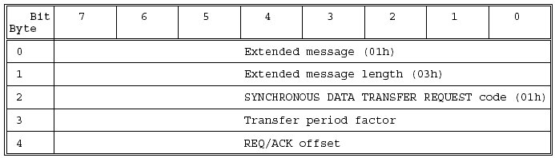

A SYNCHRONOUS DATA TRANSFER REQUEST (SDTR) message (see table above) exchange shall be initiated by an SCSI device whenever a previously-arranged data transfer agreement may have become invalid. The agreement becomes invalid after any condition which may leave the data transfer agreement in an indeterminate state such as:

a) after a hard reset condition;
b) after a BUS DEVICE RESET message and;
c) after a power cycle.

In addition, an SCSI device may initiate an SDTR message exchange whenever it is appropriate to negotiate a new data transfer agreement (either synchronous or asynchronous). SCSI devices that are capable of synchronous data transfers shall not respond to an SDTR message with a MESSAGE REJECT message.

NOTES:
1) Renegotiation at every selection is not recommended, since a significant performance impact is likely.
2) Due to historical problems with early host adapters that could not accept an SDTR message, some targets may not initiate synchronous negotiation after a power cycle as required by this standard. Host adapters that support synchronous mode may avoid the ensuing failure modes when the target is independently power cycled by initiating a synchronous negotiation on each REQUEST SENSE and INQUIRY command.
The SDTR message exchange establishes the permissible transfer periods and the REQ/ACK offsets for all logical units and target routines on the two devices. This agreement only applies to data phases. The transfer period factor times four is the value of the transfer period. The transfer period is the minimum time
allowed between leading edges of successive REQ pulses and of successive ACK pulses to meet the device requirements for successful reception of data. The REQ/ACK offset is the maximum number of REQ pulses allowed to be outstanding before the leading edge of its corresponding ACK pulse is received at the target. This value is chosen to prevent overflow conditions in the device’s reception buffer and offset counter. A REQ/ACK offset value of zero shall indicate asynchronous data transfer mode; a value of FFh shall indicate unlimited REQ/ACK offset.
The originating device (the device that sends the first of the pair of SDTR messages) sets its values according to the rules above to permit it to receive data successfully. If the responding device can also receive data successfully with these values (or smaller transfer periods or larger REQ/ACK offsets or both), it returns the same values in its SDTR message. If it requires a larger transfer period, a smaller REQ/ACK offset, or both in order to receive data successfully, it substitutes values in its SDTR message as required, returning unchanged any value not required to be changed. Each device when transmitting data shall respect the limits set by the other’s SDTR message, but it is
permitted to transfer data with larger transfer periods, smaller REQ/ACK offsets, or both than specified in the other’s SDTR message. The successful completion of an exchange of SDTR messages implies an agreement as follows:

Responding device SDTR response Implied agreement

a) Non-zero REQ/ACK offset Each device transmits data with a transfer period equal to or greater than and a REQ/ACK offset equal to or less than the values received in the other device’s SDTR message.

b) REQ/ACK offset equal to zero Asynchronous transfer

c) MESSAGE REJECT message Asynchronous transfer If the initiator recognizes that negotiation is required, it asserts the ATN signal and sends a SDTR message to begin
the negotiating process. After successfully completing the MESSAGE OUT phase, the target shall respond with the proper SDTR message. If an abnormal condition prevents the target from returning an appropriate response, both devices shall go to asynchronous data transfer mode for data transfers between the two devices. Following target response (1) above, the implied agreement for synchronous operation shall be considered to be
negated by both the initiator and the target if the initiator asserts the ATN signal and the first message out is either MESSAGE PARITY ERROR or MESSAGE REJECT. In this case, both devices shall go to asynchronous data transfer mode for data transfers between the two devices. For the MESSAGE PARITY ERROR case, the implied agreement
shall be reinstated if a retransmittal of the second of the pair of messages is successfully accomplished. After a vendor-specific number of retry attempts (greater than zero), if the target receives a MESSAGE PARITY ERROR message, it shall terminate the retry activity. This may be done either by changing to any other information transfer
phase and transferring at least one byte of information or by going to the BUS FREE phase. The initiator shall accept such action as aborting the negotiation, and both devices shall go to asynchronous data transfer mode for data transfers between the two devices.
If the target recognizes that negotiation is required, it sends an SDTR message to the initiator. Prior to releasing the ACK signal on the last byte of the SDTR message from the target, the initiator shall assert the ATN signal and respond with its SDTR message or with a MESSAGE REJECT message. If an abnormal condition prevents the initiator from
returning an appropriate response, both devices shall go to asynchronous data transfer mode for data transfers between the two devices.

Following an initiator’s responding SDTR message, an implied agreement for synchronous operation shall not be considered to exist until the target leaves the MESSAGE OUT phase, indicating that the target has accepted the negotiation. After a vendor-specific number of retry attempts (greater than zero), if the target has not received the initiator’s responding SDTR message, it shall go to the BUS FREE phase without any further information transfer attempt (see 6.1.1). This indicates that a catastrophic error condition has occurred. Both devices shall go to asynchronous data transfer mode for data transfers between the two devices. If, following an initiator’s responding SDTR message, the target shifts to MESSAGE IN phase and the first message in is MESSAGE REJECT, the implied agreement shall be considered to be negated and both devices shall go to
asynchronous data transfer mode for data transfers between the two devices. The implied synchronous agreement shall remain in effect until a BUS DEVICE RESET message is received, until a hard reset condition occurs, or until one of the two SCSI devices elects to modify the agreement. The default data transfer mode is asynchronous data transfer mode. The default data transfer mode is entered at power on, after a BUS DEVICE RESET message, or after a hard reset condition.

TERMINATE I/O PROCESS

The TERMINATE I/O PROCESS message is sent from the initiator to the target to terminate the current I/O process without corrupting the medium.
With the following exceptions, the target shall terminate the current I/O process and return COMMAND TERMINATED status. The sense key shall be set to NO SENSE. The additional sense code and qualifier are set to I/O PROCESS TERMINATED.

If the associated I/O process involves a data phase, the target shall set the valid bit in the sense data to one and set the information field as follows:

a) If the command descriptor block specifies an allocation length or parameter list length, the information field shall be set to the difference (residue) between the number of bytes successfully transferred and the requested length.

b) If the command descriptor block specifies a transfer length field, the information field shall be set as defined in the REQUEST SENSE command.

If an error is detected for the associated I/O process the target shall ignore the TERMINATE I/O PROCESS message.If the operation requested for the associated I/O process has been completed but status has not been returned, the target shall ignore the TERMINATE I/O PROCESS message.

If the target does not support this message or is unable to stop the current I/O process, it shall send a MESSAGE REJECT message to the initiator and continue the I/O process in a normal manner.
The effect of a TERMINATE I/O PROCESS message on the command queue depends on the queue error recovery option specified in the control mode page and on whether or not a contingent allegiance condition is generated.

NOTE: The TERMINATE I/O PROCESS message provides a means for the initiator to request the target to reduce the transfer length of the current command to the amount that has already been transferred. The initiator can use the sense data to determine the actual number of bytes or blocks that have been transferred. This message is normally used by the initiator to stop a lengthy read, write, or verify operation when a higher-priority command is available to be executed. It is up to the initiator to complete the terminated command at a later time, if required.

WIDE DATA TRANSFER REQUEST message

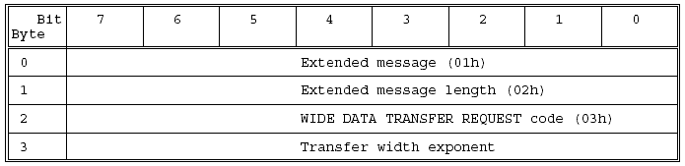

A WIDE DATA TRANSFER REQUEST (WDTR) message (see table above) exchange shall be initiated by an SCSI device whenever a previously-arranged transfer width agreement may have become invalid. The agreement becomes invalid
after any condition which may leave the data transfer agreement in an indeterminate state such as:

a) after a hard reset condition;
b) after a BUS DEVICE RESET message and;
c) after a power cycle.

In addition, an SCSI device may initiate a WDTR message exchange whenever it is appropriate to negotiate a new transfer width agreement. SCSI devices that are capable of wide data transfers (greater than eight bits) shall not respond to a WDTR message with a MESSAGE REJECT message.

NOTE: Renegotiation at every selection is not recommended, since a significant performance impact is likely. The WDTR message exchange establishes an agreement between two SCSI devices on the width of the data path to be used for DATA phase transfers between the two devices. This agreement applies to DATA IN and DATA OUT
phases only. All other information transfer phases shall use an eight-bit data path.

If an SCSI device implements both wide data transfer option and synchronous data transfer option, then it shall
negotiate the wide data transfer agreement prior to negotiating the synchronous data transfer agreement.

If a synchronous data transfer agreement is in effect, then an SCSI device that accepts a WDTR message shall reset the synchronous agreement to asynchronous mode.

The transfer width is two to the transfer width exponent bytes wide. The transfer width that is established applies to
all logical units on both SCSI devices.

Valid transfer widths are:
8 bits (m = 00h)
16 bits (m = 01h)
32 bits (m = 02h).

Values of m greater than 02h are reserved.

The originating SCSI device (the SCSI device that sends the first of the pair of WDTR messages) sets its transfer width value to the maximum data path width it elects to accommodate. If the responding SCSI device can also accommodate this transfer width, it returns the same value in its WDTR message. If it requires a smaller transfer width, it substitutes the smaller value in its WDTR message. The successful completion of an exchange of WDTR messages implies an agreement as follows:

Responding device WDTR response Implied agreement:

a) Non-zero transfer width Each device transmits and receives data with a transfer width equal to the responding SCSI device’s transfer width.

b) Transfer width equal to zero Eight-bit data transfer

c) MESSAGE REJECT message Eight-bit data transfer If the initiator recognizes that negotiation is required, it asserts the ATN signal and sends a WDTR message to begin
the negotiating process. After successfully completing the MESSAGE OUT phase, the target shall respond with the proper WDTR message. If an abnormal condition prevents the target from returning an appropriate response, both devices shall go to eight-bit data transfer mode for data transfers between the two devices. Following target response 1) above, the implied agreement for wide data transfers shall be considered to be negated
by both the initiator and the target if the initiator asserts ATN and the first message out is either MESSAGE PARITY ERROR or MESSAGE REJECT. In this case, both devices shall go to eight-bit data transfer mode for data transfers between the two devices. For the MESSAGE PARITY ERROR case, the implied agreement shall be reinstated if a
retransmittal of the second of the pair of messages is successfully accomplished. After a vendor-specific number of retry attempts (greater than zero), if the target receives a MESSAGE PARITY ERROR message, it shall terminate the retry activity. This may be done either by changing to any other information transfer phase and transferring at least
one byte of information or by going to the BUS FREE phase.

The initiator shall accept such action as aborting the negotiation, and both devices shall go to eight-bit data transfer mode for data transfers between the two devices.

If the target recognizes that negotiation is required, it sends a WDTR message to the initiator. Prior to releasing the ACK signal on the last byte of the WDTR message from the target, the initiator shall assert the ATN signal and respond with its WDTR message or with a MESSAGE REJECT message. If an abnormal condition prevents the
initiator from returning an appropriate response, both devices shall go to eight-bit data transfer mode for data transfers between the two devices.

Following an initiator’s responding WDTR message, an implied agreement for wide data transfer operation shall not be considered to exist until the target leaves the MESSAGE OUT phase, indicating that the target has accepted the negotiation. After a vendor-specific number of retry attempts (greater than zero), if the target has not received the
initiator’s responding WDTR message, it shall go to the BUS FREE phase without any further information transfer attempt. This indicates that a catastrophic error condition has occurred. Both devices shall go to eight-bit data transfer mode for data transfers between the two devices.

If, following an initiator’s responding WDTR message, the target shifts to MESSAGE IN phase and the first message in is MESSAGE REJECT, the implied agreement shall be considered to be negated and both devices shall go to eightbit data transfer mode for data transfers between the two devices
.
The implied transfer width agreement shall remain in effect until a BUS DEVICE RESET message is received, until a hard reset condition occurs, or until one of the two SCSI devices elects to modify the agreement. The default data transfer width is eight-bit data transfer mode. The default data transfer mode is entered at power on, after a BUS
DEVICE RESET message, or after a hard reset condition.

SCSI BUS Status codes

Status byte format

Status byte codes

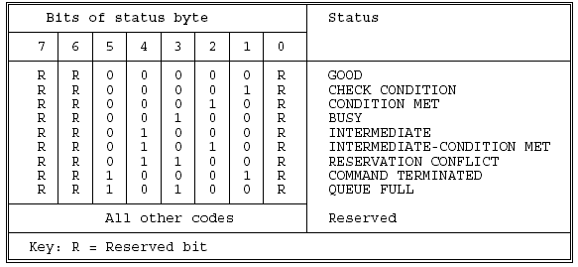

Definition of SCSI status codes

- GOOD: This status indicates that the target has successfully completed the command.
- CHECK CONDITION: This status indicates that a contingent allegiance condition has occurred
- CONDITION MET: This status or INTERMEDIATE-CONDITION MET is returned whenever the requested
- operation is satisfied (see the SEARCH DATA and PREFETCH commands).
- BUSY: This status indicates that the target is busy. This status shall be returned whenever a target is unable
- to accept a command from an otherwise acceptable initiator (i.e. no reservation conflicts). The recommended initiator
- recovery action is to issue the command again at a later time.
- INTERMEDIATE: This status or INTERMEDIATE-CONDITION MET shall be returned for every successfully completed command in a series of linked commands (except the last command), unless the command is terminated with CHECK CONDITION, RESERVATION CONFLICT, or COMMAND TERMINATED status. If INTERMEDIATE or INTERMEDIATE-CONDITION MET status is not returned, the series of linked commands is terminated and the I/O process is ended.
- INTERMEDIATE-CONDITION MET: This status is the combination of the CONDITION MET and INTERMEDIATE statuses.
- RESERVATION CONFLICT: This status shall be returned whenever an initiator attempts to access a logical unit or an extent within a logical unit that is reserved with a conflicting reservation type for another SCSI device (see the RESERVE and RESERVE UNIT commands). The recommended initiator recovery action is to issue the command again at a later time.
- COMMAND TERMINATED: This status shall be returned whenever the target terminates the current I/O process after receiving a TERMINATE I/O PROCESS message. This status also indicates that a contingent allegiance condition has occurred.
- QUEUE FULL: This status shall be implemented if tagged queuing is implemented. This status is returned when a SIMPLE QUEUE TAG, ORDERED QUEUE TAG, or HEAD OF QUEUE TAG message is received and the command queue is full. The I/O process is not placed in the command queue.

SCSI Commands

Introduction
The purpose of all of the messages and status defined previously in this document is to allow delivery of commands to a target. Commands are defined in Command Descriptor Block, CDB format and exist in 6, 10, 12 and 16 byte formats. 6 byte commands are legacy SCSI-1 and should be strongly avoided. Our design will not contain them. Thusly, we only consider 10, 12 and 16 byte CDB’s.

10 byte CDB

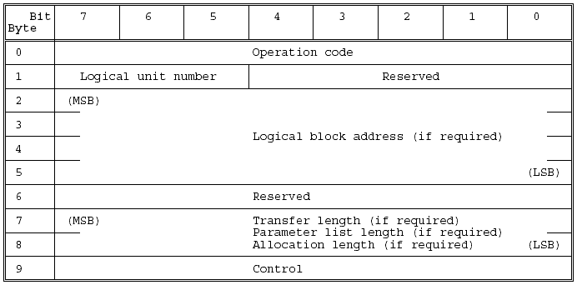

12 byte CDB

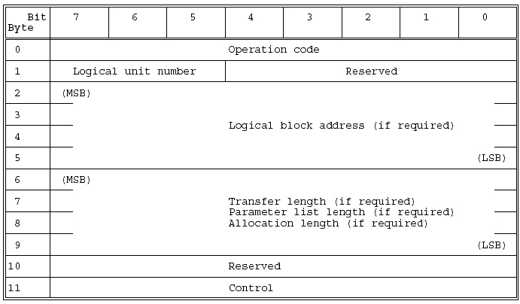

16 byte CDB (SCSI-3) To be added

SCSI Command hierarchy

SCSI commands are grouped by “general” commands which are implemented in all devices and by device specific commands for classifications of devices.

Useful classifications are DISKS, TAPE DRIVES, SCANNERS, OPTICAL, PRINTERS, ect.
Of greatest usefulness to the storage industry are the “DIRECT ACCESS” and “CDROM” commands. Direct access infers disk drive. These groups are the ones BigSur must implement first. Of these three commands for “DISK DRIVES” are most important followed by RAID and then CDROM.. Marketing Department will make the final determination. From an engineering perspective, any commands dealing with disk devices are important.

All SCSI devices implement a subset of the table below:

Commands for all device types

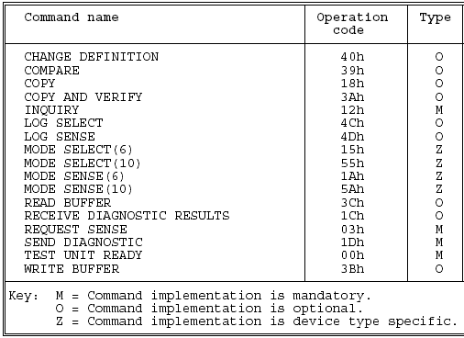

Direct access commands (disk drive)

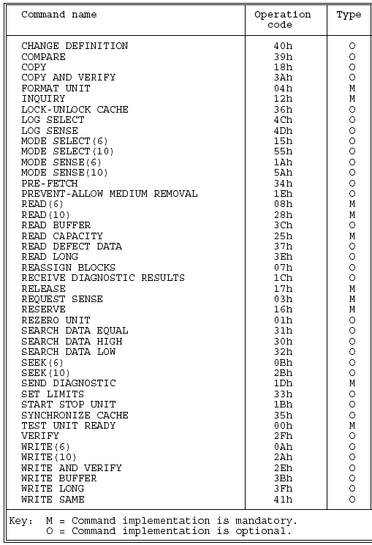

Sequential Devices (tape drive)

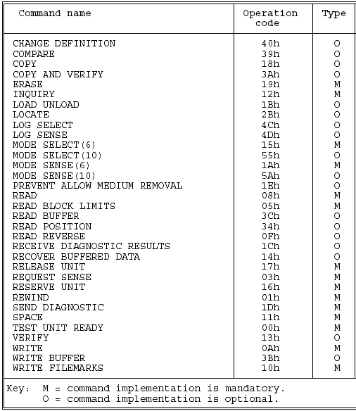

SCSI State Machine Architecture

This section of the paper will attempt to put a stake in the ground for the definition of the dividing line between the deterministic portion of the state machine which can iterate without external intervention and that which is volatile and exempt from hardware acceleration.

Consideration is given to components of the SCSI Interlock Protocol (SIP) which can be cast in silicon.

The messages and status can all be saved in tables in the hardware for rapid reply and execution as these entities are fixed.

At this time, the message table is represented for consideration. We are interested in the messages which originate from the initiator as from the perspective of the BigSur chip, we are “serving” SCSI physical bus requests to clients. Clients are remote systems on fibre channel system or from the Ethernet iSCSI systems. The point of the SCSI state engine is to have a SCSI implementation which is capable of keeping up with multiple requests from Ethernet iSCSI clients and from Fibrechannel clients. As a SCSI server, we are a SCSI initiator and are reading and writing data from target SCSI devices on behalf of our clients.

We can not predict the intention of our clients and what type of requests we will be presented with. We assume we are presented with a CDB’s from the iSCSI Ethernet side and from the Fibre channel side

To serve SCSI requests rapidly, we can move the SCSI interlock Protocol (SIP) to hardware.

This section explores the needs of the SCSI environment as defined by the interlocking messaging environment necessary for state transition.

I_T_L_Q Nexus basic host requirements

Introduction

When the physical SCSI portion of the BigSur chip receives a CDB to process from either Ethernet or Fibrechannel, ports, the SCSI server, (remember, we are a SCSI server serving our Fibrechannel and iSCSI Ethernet clients with data from our [target] SCSI devices), the CDB must be determined from what source it same from.

In the nomenclature and spirit of the SCSI-2 spec, we will have to increase specificity of the connection to include the addition of the remote source. Remote sources are the remote computer connected via iSCSI/Ethernet ports or the remote computer connected via the Fibre Chanel ports.

Nexus expanded for FC and iSCSI

In the SCSI-2 spec, a SCSI process or connection is defined by the nexus of the Initiator and the Target. This is an I_T nexus. The Initiator with respect to this project is the actual “server” environment within the BigSur chip. The chip is called the Initiator. The target is still the traditional SCSI target which is a SCSI device on the SCSI bus provided by our SCSI hardware implementation on the BigSur chip.

The “L” portion is present if the target device – ie disk drive or generic SCSI device supports LUN’s.

Lastly, the “Q” portion of the nexus/connection is the “command queue” . If the device supports command queuing, then commands are tagged (commands meaning CDB’s) and placed into a queue hosted on the target device (disk, tape drive, ect). It is up then to that target to execute the commands in its queue when it sees fit.

The I_T_L_Q nexus is then the worst case connection as defined by a traditional SCSI device.

For our BigSur “SCSI Server” environment, we have to keep unique track of each SCSI connection requested of our SCSI server. Connections are originating from Fibrechannel SCSI clients and from iSCSI clients from the Ethernet.

Example expanded Nexus

The nexus is expanded to contain a preamble specifying the source of the SCSI request. The nexus may look like:

- “AL-ID”_”FC_PORT”_”FC-CARD”_I_T_L_Q for Fibre Channel clients.
- “IP address”_”NIC-PORT”_”NIC-CARD”_I_T_L_Q for iSCSI clients.

When a request from either of the above external clients is received, the BigSur SCSI server chip state SCSI server environment first scans a list of known nexus which are still open. The list of nexus is the routing information of how to send the CDB to the proper target for processing.

A connection will be maintained open for a large synchronous data transfer.

If the connection is not found in the nexus table, it is considered unique and added to the table. It will be present in the table until the SCSI state machine reaches the bus free state at which time it will be purged (deleted).

Concept of SCSI process

With respect to a SCSI server, (our SCSI server serving FC and iSCSI clients), we look at each connection as a process. The process is responsible for maintaining state information of the SCSI connection. Each process has three sets of pointers for command, data and status. The command pointer points to the CDB, the status pointer to the status data structure and the data pointer to the data buffer area for the process. At any point in time, one SCSI process is active and only one. These pointers are called the active pointers. The active pointers are copied from the pointers stored in the Nexus table (see below).

Contents of Nexus table

The nexus table must contain state variables to maintain the viability of the connection as managed by the messaging state machine and requests presented via messaging by the target(s). Messaging is employed by the SCSI bus on behalf of targets to allow the inititator to react to abnormal conditions within the target and to control the normal flow of the I_T, I_T_L or I_T_L_Q connection or “process” as called in SCSI-3.

Address | Port | I/O Processor | I | T | L | Q | Command | Data | Status
15.3.2.5 | 0 | 0 | 7 | 3 | 0 | 0 | Addr c0 | Addr d0 | Addr s0
241 | 3 | 1 | 7 | 0 | 1 | 0 | Addr c1 | Addr d1 | Addr s1
Fabric | 11 | 1 | 7 | 0 | 1 | 0 | Addr c2 | Addr d2 | Addr s2

The above nexus table will grow with in the BigSur chip SCSI server environment to the maximum number or limit of SCSI connections which we support. If the table is full, the connection limit is maxed out and we reject the request.

In our hypothetical nexus table, the first row is an active iSCSI connection. The second connection is to a Fibrechannel Arbitrated Loop device at ALPA ID 241. The third and final entry is a Fabric connection.

Note – Host adapters in our hardware implementation may have multiple ports. We may also have the concept of multiple I/O processors of the same type within our chip, depending on custom build to meet specific customer orders.

Implementing SCSI BUS STATES in hardware

To be decided. Mechanism in hardware to build the process ID for the extended I_T_L_Q nexus (with preamble as discussed above).

To be decided. Method in hardware for searching nexus table and returning valid process id/nexus or inserting this new ID.

To be decided. Method in hardware to make the active pointers – data, command and status equal to the selected pointers from the nexus table.

Now, begin states in hardware below:

STATE: “BUS FREE” → “ARBITRATION”

This is all done in hardware. No messages, status or CDB’s needed.
Follow the state outlined below:

The ARBITRATION phase allows one SCSI device to gain control of the SCSI bus so that it can initiate or resume an I/O process.
The procedure for an SCSI device to obtain control of the SCSI bus is as follows:

a) The SCSI device shall first wait for the BUS FREE phase to occur. The BUS FREE phase is detected whenever both the BSY and SEL signals are simultaneously and continuously false for a minimum of a bus settle delay.

NOTE: This bus settle delay is necessary because a transmission line phenomenon known as a wired-OR glitch may
cause the BSY signal to briefly appear false, even though it is being driven true.

b) The SCSI device shall wait a minimum of a bus free delay after detection of the BUS FREE phase (i.e. after the BSY and SEL signals are both false for a bus settle delay) before driving any signal.

c) Following the bus free delay in step (b), the SCSI device may arbitrate for the SCSI bus by asserting both the BSY signal and its own SCSI ID, however the SCSI device shall not arbitrate (i.e. assert the BSY signal and its SCSI ID) if more than a bus set delay has passed since the BUS FREE phase was last observed.
NOTE: There is no maximum delay before asserting the BSY signal and the SCSI ID following the bus free delay in step (b) as long as the bus remains in the BUS FREE phase. However, SCSI devices that delay longer than a bus settle delay plus a bus set delay from the time when the BSY and SEL signals first become false may fail to participate in arbitration when competing with faster SCSI devices.

d) After waiting at least an arbitration delay (measured from its assertion of the BSY signal) the SCSI device shall examine the DATA BUS. If a higher priority SCSI ID bit is true on the DATA BUS (DB(7) is the highest), then the SCSI device has lost the arbitration and the SCSI device may release its signals and return to step (a). If
no higher priority SCSI ID bit is true on the DATA BUS, then the SCSI device has won the arbitration and it shall assert the SEL signal. Any SCSI device other than the winner has lost the arbitration and shall release the BSY signal and its SCSI ID bit within a bus clear delay after the SEL signal becomes true. An SCSI device that loses arbitration may return to step (a).
NOTES Step d) above requires that any device complete the arbitration phase to the point of SEL being asserted if it begins the arbitration phase as stated in step c). This precludes the possibility of the bus being hung.

It is recommended that new implementations wait for the SEL signal to become true before releasing the BSY signal and SCSI ID bit when arbitration is lost.

The SCSI device that wins arbitration shall wait at least a bus clear delay plus a bus settle delay after asserting
the SEL signal before changing any signals.

NOTE : The SCSI ID bit is a single bit on the DATA BUS that corresponds to the SCSI device’s unique SCSI address. All other DATA BUS bits shall be released by the SCSI device. Parity is not valid during the ARBITRATION phase. During the ARBITRATION phase, DB(P) may be released or asserted, but shall not be actively driven false.

STATE “ARBITRATION” → “SELECTION”

The SELECTION phase allows an initiator to select a target for the purpose of initiating some target function (e.g., READ or WRITE command). During the SELECTION phase the I/O signal is negated so that this phase can be distinguished from the RESELECTION phase. The SCSI device that won the arbitration has both the BSY and SEL signals asserted and has delayed at least a bus clear delay plus a bus settle delay before ending the ARBITRATION phase. The SCSI device that won the arbitration becomes an initiator by not asserting the I/O signal. The initiator shall set the DATA BUS to a value that is the OR of its SCSI ID bit and the target’s SCSI ID bit and it shall assert the ATN signal (indicating that a MESSAGE OUT phase is to follow the SELECTION phase). The initiator shall then wait at least two deskew delays and release the BSY signal. The initiator shall then wait at least a bus settle delay before looking for a response from the target.

The target shall determine that it is selected when the SEL signal and its SCSI ID bit are true and the BSY and I/O signals are false for at least a bus settle delay. The selected target may examine the DATA BUS in order to determine the SCSI ID of the selecting initiator. The selected target shall then assert the BSY signal within a selection abort time
of its most recent detection of being selected; this is required for correct operation of the selection time-out procedure.

The target shall not respond to a selection if bad parity is detected. Also, if more than two SCSI ID bits are on the DATA BUS, the target shall not respond to selection.

NOTE: Although an SCSI-2 initiator may not use the single initiator option or the selection without asserting ATN option of SCSI-1, an SCSI-2 target may elect to support these options for compatibility with SCSI-1 initiators. When doing so the SCSI-2 target responds as described in the SCSI-1 standard. No less than two deskew delays after the initiator detects the BSY signal is true, it shall release the SEL signal and
may change the DATA BUS. The target shall wait until the SEL signal is false before asserting the REQ signal to enter an information transfer phase.

SELECTION time-out procedure
Two optional selection time-out procedures are specified for clearing the SCSI bus if the initiator waits a minimum of a selection time-out delay and there has been no BSY signal response from the target:

a) Optionally, the initiator shall assert the RST signal.

b) Optionally, the initiator shall continue asserting the SEL and ATN signals and shall release the DATA BUS. If the initiator has not detected the BSY signal to be true after at least a selection abort time plus two deskew delays, the initiator shall release the SEL and ATN signals allowing the SCSI bus to go to the BUS FREE phase. SCSI devices shall ensure that when responding to selection that the selection was still valid within a selection abort time of their assertion of the BSY signal. Failure to comply with this requirement could result in an improper selection (two targets connected to the same initiator, wrong target connected to an initiator, or a target connected to no initiator).

STATE “ARBITRATION” → “RESELECTION”

RESELECTION is an optional phase that allows a target to reconnect to an initiator for the purpose of continuing some operation that was previously started by the initiator but was suspended by the target, (i.e. the target disconnected by allowing a BUS FREE phase to occur before the operation was complete).

RESELECTION

Upon completing the ARBITRATION phase, the winning SCSI device has both the BSY and SEL signals asserted and has delayed at least a bus clear delay plus a bus settle delay. The winning SCSI device becomes a target by asserting the I/O signal. The winning SCSI device shall also set the DATA BUS to a value that is the logical OR of its SCSI ID bit and the initiator’s SCSI ID bit. The target shall wait at least two deskew delays and release the BSY signal. The target shall then wait at least a bus settle delay before looking for a response from the initiator. The initiator shall determine that it is reselected when the SEL and I/O signals and its SCSI ID bit are true and the BSY
signal is false for at least a bus settle delay. The reselected initiator may examine the DATA BUS in order todetermine the SCSI ID of the reselecting target. The reselected initiator shall then assert the BSY signal within a selection abort time of its most recent detection of being reselected; this is required for correct operation of the time-out
procedure. The initiator shall not respond to a RESELECTION phase if bad parity is detected. Also, the initiator shall not respond to a RESELECTION phase if other than two SCSI ID bits are on the DATA BUS.
After the target detects the BSY signal is true, it shall also assert the BSY signal and wait at least two deskew delays and then release the SEL signal. The target may then change the I/O signal and the DATA BUS. After the reselected initiator detects the SEL signal is false, it shall release the BSY signal. The target shall continue asserting the BSY
signal until it relinquishes the SCSI bus.

NOTE: When the target is asserting the BSY signal, a transmission line phenomenon known as a wired-OR glitch may cause the BSY signal to appear false for up to a round-trip propagation delay following the release of the BSY signal by the initiator. This is the reason why the BUS FREE phase is recognized only after both the BSY and SEL signals are continuously false for a minimum of a bus settle delay. Cables longer than 25 m should not be used even if the chosen driver, receiver, and cable provide adequate noise margins, because they increase the duration of the glitch and could cause
SCSI devices to inadvertently detect the BUS FREE phase.

RESELECTION time-out procedure

Two optional RESELECTION time-out procedures are specified for clearing the SCSI bus during a RESELECTION phase if the target waits a minimum of a selection time-out delay and there has been no BSY signal response from the initiator:

a) Optionally, the target shall assert the RST signal.

b) Optionally, the target shall continue asserting the SEL and I/O signals and shall release all DATA BUS signals. If the target has not detected the BSY signal to be true after at least a selection abort time plus two deskew delays, the target shall release the SEL and I/O signals allowing the SCSI bus to go to the BUS FREE phase. SCSI devices that respond to the RESELECTION phase shall ensure that the reselection was still valid within a selection abort time of their assertion of the BSY signal. Failure to comply with this requirement could result in an improper reselection (two initiators connected to the same target or the wrong initiator connected to a
target).

Information transfer phases

The COMMAND, DATA, STATUS, and MESSAGE phases are all grouped together as the information transfer phases because they are all used to transfer data or control information via the DATA BUS. The actual content of the information is beyond the scope of this section.
The C/D, I/O, and MSG signals are used to distinguish between the different information transfer phases ( table). The target drives these three signals and therefore controls all changes from one phase to another. The initiatorn can request a MESSAGE OUT phase by asserting the ATN signal, while the target can cause the BUS FREE phase
by releasing the MSG, C/D, I/O, and BSY signals.

The information transfer phases use one or more REQ/ACK handshakes to control the information transfer. Each REQ/ACK handshake allows the transfer of one byte of information. During the information transfer phases the BSY signal shall remain true and the SEL signal shall remain false. Additionally, during the information transfer phases,
the target shall continuously envelope the REQ/ACK handshake(s) with the C/D, I/O, and MSG signals in such a manner that these control signals are valid for a bus settle delay before the assertion of the REQ signal of the first handshake and remain valid until after the negation of the ACK signal at the end of the handshake of the last transfer
of the phase.

NOTES After the negation of the ACK signal of the last transfer of the phase, the target may prepare for a new phase by asserting or negating the C/D, I/O, and MSG signals. These signals may be changed together or individually. They may be changed
in any order and may be changed more than once. It is desirable that each line change only once. A new phase does not begin until the REQ signal is asserted for the first byte of the new phase.

A phase is defined as ending when the C/D, I/O, or MSG signals change after the negation of the ACK signal. The time between the end of a phase and the assertion of the REQ signal beginning a new phase is undefined. An initiator is allowed
to anticipate a new phase based on the previous phase, the expected new phase, and early information provided by changes in the C/D, I/O, and MSG signals. However, the anticipated phase is not valid until the REQ signal is asserted at the beginning of the next phase.

Information transfer phases

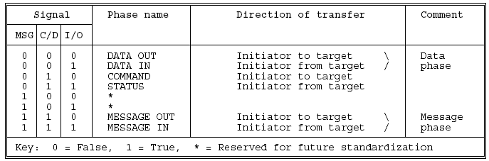

Asynchronous information transfer

The target shall control the direction of information transfer by means of the I/O signal. When the I/O signal is true, information shall be transferred from the target to the initiator. When the I/O signal is false, information shall be transferred from the initiator to the target.

If the I/O signal is true (transfer to the initiator), the target shall first drive the DB(7-0,P) signals to their desired values, delay at least one deskew delay plus a cable skew delay, then assert the REQ signal. The DB(7-0,P) signals shall remain valid until the ACK signal is true at the target. The initiator shall read the DB(7-0,P) signals after the REQ
signal is true, then indicate its acceptance of the data by asserting the ACK signal.

When the ACK signal becomes true at the target, the target may change or release the DB(7-0,P) signals and shall negate the REQ signal. After the REQ signal is false the initiator shall then negate the ACK signal. After the ACK signal is false the target may continue the transfer by driving the DB(7-0,P) signals and asserting the REQ signal, as described above.

If the I/O signal is false (transfer to the target) the target shall request information by asserting the REQ signal. The initiator shall drive the DB(7-0,P) signals to their desired values, delay at least one deskew delay plus a cable skew delay and assert the ACK signal. The initiator shall continue to drive the DB(7-0,P) signals until the REQ signal is
false. When the ACK signal becomes true at the target, the target shall read the DB(7-0,P), signals then negate the REQ signal. When the REQ signal becomes false at the initiator, the initiator may change or release the DB(7-0,P) signals and shall negate the ACK signal. After the ACK signal is false the target may continue the transfer by asserting the REQ signal, as described above.

Synchronous data transfer
Synchronous data transfer is optional and is only used in data phases. It shall be used in a data phase if a synchronous data transfer agreement has been establishe. The agreement specifies the REQ/ACK offset and the minimum transfer period.

The REQ/ACK offset specifies the maximum number of REQ pulses that can be sent by the target in advance of the number of ACK pulses received from the initiator, establishing a pacing mechanism. If the number of REQ pulses exceeds the number of ACK pulses by the REQ/ACK offset, the target shall not assert the REQ signal until after the leading edge of the next ACK pulse is received. For successful completion of the data phase is that the number of ACK and REQ pulses shall be equal.
The target shall assert the REQ signal for a minimum of an assertion period. The target shall then wait at least the greater of a transfer period from the last transition of the REQ signal to true or a minimum of a negation period from the last transition of the REQ signal to false before again asserting the REQ signal.

The initiator shall send one pulse on the ACK signal for each REQ pulse received. The ACK signal may be asserted as soon as the leading edge of the corresponding REQ pulse has been received. The initiator shall assert the ACK signal for a minimum of an assertion period. The initiator shall wait at least the greater of a transfer period from the
last transition of the ACK signal to true or for a minimum of a negation period from the last transition of the ACK signal to false before asserting the ACK signal.

If the I/O signal is true (transfer to the initiator), the target shall first drive the DB(7-0,P) signals to their desired values, wait at least one deskew delay plus one cable skew delay, then assert the REQ signals. The DB(7-0,P) signals shall be held valid for a minimum of one deskew delay plus one cable skew delay plus one hold time after the assertion
of the REQ signal.

The target shall assert the REQ signal for a minimum of an assertion period. The target may then negate the REQ signal and change or release the DB(7-0,P) signals. The initiator shall read the value on the DB(7-0,P) signals within one hold time of the transition of the REQ signal to true. The initiator shall then respond with an ACK pulse.

If the I/O signal is false (transfer to the target), the initiator shall transfer one byte for each REQ pulse received. After receiving the leading edge of a REQ pulse, the initiator shall first drive the DB(7-0,P) signals to their desired values, delay at least one deskew delay plus one cable skew delay, then assert the ACK signal. The initiator shall hold the
DB(7-0,P) signals valid for at least one deskew delay plus one cable skew delay plus one hold time after the assertion
of the ACK signal.

The initiator shall assert the ACK signal for a minimum of an assertion period. The initiator may then negate the ACK signal and may change or release the DB(7-0,P) signals. The target shall read the value of the DB(7-0,P) signals within one hold time of the transition of the ACK signal to true.

NOTE: The description in SCSI-1 allowed some implementors to presume that the leading edge of the first REQ pulse beyond the REQ/ACK offset agreement would not occur until after the trailing edge of the last ACK pulse within the agreement. Devices implemented with this understanding may be subject to data destruction when in synchronous data transfer mode with devices that issue the leading edge of the next REQ pulse, at the boundary of the agreement, as soon as the leading edge of the last ACK pulse within the agreement is received. Implementors using devices of the former type
in initiator designs may insure data integrity by restricting the synchronous offset agreement to values smaller than the maximum nominally offered by their device.

Wide data transfer

Wide data transfer is optional and may be used in the DATA phase only if a non-zero wide data transfer agreement is in effect (see WIDE DATA TRANSFER REQUEST message.. The messages determine the use of wide mode by both SCSI devices and establish a data path width to be used during the DATA phase. Wide data transfers of 16- or 32-bits may be established. Targets and initiators that support 32-bit wide transfers
should also support 16-bit wide transfers. All SCSI devices shall support 8-bit data transfers.

During 16-bit wide data transfers, the first logical data byte for each data phase shall be transferred across the DB(7-0,P) signals on the A cable and the second logical data byte shall be transferred across the DB(15-8,P1) signals on the B cable. Subsequent pairs of data bytes are likewise transferred in parallel across the A and B cables (see figure
). NOTE 27 X3T9.2 is documenting an alternate 16-bit single-cable solution and an alternate 32-bit solution and expects to be able to remove the B cable definition in a future version of SCSI.

During 32-bit wide data transfers, the first logical data byte for each data phase shall be transferred across the DB(7-0,P) signals on the A cable and the second, third, and fourth logical data bytes shall be transferred across the DB(15-
8,P1), DB(23-16,P2), and DB(31-24,P3) signals, respectively, on the B cable.

Subsequent groups of four data bytes are likewise transferred in parallel across the A and B cables (see figure below).

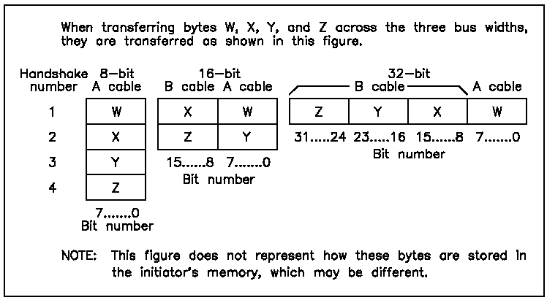

Wide SCSI byte ordering

If the last data byte transferred does not fall on the DB(15-8,P1) signals for a 16-bit wide transfer or the DB(31-24,P3) signals for a 32-bit wide transfer, then the values of the remaining higher-numbered bits are undefined. However, parity bits for these undefined bytes shall be valid for whatever data is placed on the bus.

To ensure proper data integrity, certain sequence requirements shall be met between the REQ/ACK handshakes on the A cable and the REQB/ACKB handshakes on the B cable:

a) The REQB and ACKB signals shall only be asserted during data phases while a nonzero wide data transfer agreement is in effect. These signals shall not be asserted during other phases.

b) The same information transfer mode (asynchronous or synchronous) shall be used for both the A cable and the B cable. If synchronous data transfer mode is in effect, the same REQ/ACK offset and transfer period shall be used for both cables.

c) The information transfer procedures defined in 6.1.5.1 and 6.1.5.2 for the A cable (the REQ, ACK, and DB(7-0,P) signals) shall also apply to the B cable (the REQB, ACKB, and DB(31-8,P1,P2,P3) signals).

The only means available for a target to manage the timing relationship between the signals on the two cables is its management of the REQ and REQB signals. Similarly, the only means for the initiator to manage the timing between the two cables is its management of the ACK and ACKB signals.

d) The target shall ensure that the number of REQ/ACK handshakes and the number of REQB/ACKB handshakes in a data phase are equal before it changes to another phase. The target shall not change the phase until the ACK and ACKB signals have both become false for the last REQ/ACK handshake and the last REQB/ACKB handshake.

NOTE: If any violations of these rules are detected by the target, the target may attempt to end the data phase and return CHECK CONDITION status. If it is impossible to correctly terminate the data phase, the target may abnormally terminate the I/O process by an unexpected disconnect. If any violations of these rules are detected by the initiator, the initiator may attempt to send an INITIATOR DETECTED ERROR message to the target. If the initiator is unable to terminate the I/O process normally, it may generate the reset condition.

SCSI Bus phase summary:

COMMAND phase

The COMMAND phase allows the target to request command information from the initiator.
The target shall assert the C/D signal and negate the I/O and MSG signals during the REQ/ACK handshake(s) of this
phase.

Data phase
The data phase is a term that encompasses both the DATA IN phase and the DATA OUT phase.

DATA IN phase

The DATA IN phase allows the target to request that data be sent to the initiator from the target.
The target shall assert the I/O signal and negate the C/D and MSG signals during the REQ/ACK handshake(s) of this
phase.

DATA OUT phase

The DATA OUT phase allows the target to request that data be sent from the initiator to the target.
The target shall negate the C/D, I/O, and MSG signals during the REQ/ACK handshake(s) of this phase.

STATUS phase

The STATUS phase allows the target to request that status information be sent from the target to the initiator.
The target shall assert the C/D and I/O signals and negate the MSG signal during the REQ/ACK handshake of this
phase.

Message phase

The message phase is a term that references either a MESSAGE IN, or a MESSAGE OUT phase. Multiple messages
may be sent during either phase. The first byte transferred in either of these phases shall be either a single-byte
message or the first byte of a multiple-byte message. Multiple-byte messages shall be wholly contained within a single
message phase.

MESSAGE IN phase

The MESSAGE IN phase allows the target to request that message(s) be sent to the initiator from the target.
The target shall assert the C/D, I/O, and MSG signals during the REQ/ACK handshake(s) of this phase.

MESSAGE OUT phase

The MESSAGE OUT phase allows the target to request that message(s) be sent from the initiator to the target. The target invokes this phase in response to the attention condition created by the initiator.

The target shall assert the C/D and MSG signals and negate the I/O signal during the REQ/ACK handshake(s) of this phase. The target shall handshake byte(s) in this phase until the ATN signal is negated, except when rejecting a message.

If the target detects one or more parity error(s) on the message byte(s) received, it may indicate its desire to retry the message(s) by asserting the REQ signal after detecting the ATN signal has gone false and prior to changing to any other phase. The initiator, upon detecting this condition, shall resend all of the previous message byte(s) in the same
order as previously sent during this phase. When resending more than one message byte, the initiator shall assert the ATN signal at least two deskew delays prior to asserting the ACK signal on the first byte and shall maintain the ATN signal asserted until the last byte is sent as described. If the target does not retry the MESSAGE OUT phase or it exhausts its retry limit it may:

a) return CHECK CONDITION status and set the sense key to ABORTED COMMAND and the additional sense code to MESSAGE ERROR or;

b) indicate an exception condition by performing an unexpected disconnect.
The target may act on messages as received as long as no parity error is detected and may ignore all remaining messages sent under one ATN condition after a parity error is detected. When a sequence of messages is resent by an initiator because of a target detected parity error, the target shall not act on any message which it acted on the first
time received. If the target receives all of the message byte(s) successfully (i.e. no parity errors), it shall indicate that it does not wish to retry by changing to any information transfer phase other than the MESSAGE OUT phase and transfer at least one
byte. The target may also indicate that it has successfully received the message byte(s) by changing to the BUS FREE phase (e.g. ABORT or BUS DEVICE RESET messages).

MESSAGE OUT

The MESSAGE OUT phase allows the target to request that message(s) be sent from the initiator to the target. The target invokes this phase in response to the attention condition created by the initiator. The target shall assert the C/D and MSG signals and negate the I/O signal during the REQ/ACK handshake(s) of this phase. The target shall handshake byte(s) in this phase until the ATN signal is negated, except when rejecting a message.

If the target detects one or more parity error(s) on the message byte(s) received, it may indicate its desire to retry the message(s) by asserting the REQ signal after detecting the ATN signal has gone false and prior to changing to any other phase. The initiator, upon detecting this condition, shall resend all of the previous message byte(s) in the same
order as previously sent during this phase. When resending more than one message byte, the initiator shall assert the ATN signal at least two deskew delays prior to asserting the ACK signal on the first byte and shall maintain the ATN signal asserted until the last byte is sent.

If the target does not retry the MESSAGE OUT phase or it exhausts its retry limit it may:

a) return CHECK CONDITION status and set the sense key to ABORTED COMMAND and the additional sense code to MESSAGE ERROR or

b) indicate an exception condition by performing an unexpected disconnect.
The target may act on messages as received as long as no parity error is detected and may ignore all remaining messages sent under one ATN condition after a parity error is detected. When a sequence of messages is resent by an initiator because of a target detected parity error, the target shall not act on any message which it acted on the first
time received. If the target receives all of the message byte(s) successfully (i.e. no parity errors), it shall indicate that it does not wish to retry by changing to any information transfer phase other than the MESSAGE OUT phase and transfer at least one
byte. The target may also indicate that it has successfully received the message byte(s) by changing to the BUS FREE phase (e.g. ABORT or BUS DEVICE RESET messages).

COMMAND phase.

The target asserts the C/D signal and negates the I/O and MSG signals for all of
the bytes transferred during this phase. The direction of transfer is from the initiator to the target. HANDSHAKE PROCEDURE: The target asserts the REQ signal. Upon detecting the REQ signal is true, the initiator drives the DATA BUS to the desired value, waits at least one deskew delay plus a cable skew delay and then asserts the ACK signal. The initiator continues to drive the DATA BUS until the REQ signal is false.

When the ACK signal is true at the target, the target reads the DATA BUS and then negates the REQ signal. When the REQ signal becomes false at the initiator, the initiator may change or release the DATA BUS and negate the ACK signal.
The target may continue to request command bytes by asserting the REQ signal again. The number of command bytes is determined by the group code (most significant 3 bits) that is contained in the first command byte.

